MLA0105-Artificial Intelligence and Expert systems for gaming
Experiment 31: Who loves whom
Code:
loves(john, mary).
loves(jane, peter).
loves(peter, alice).
loves(john, alice).
Output:
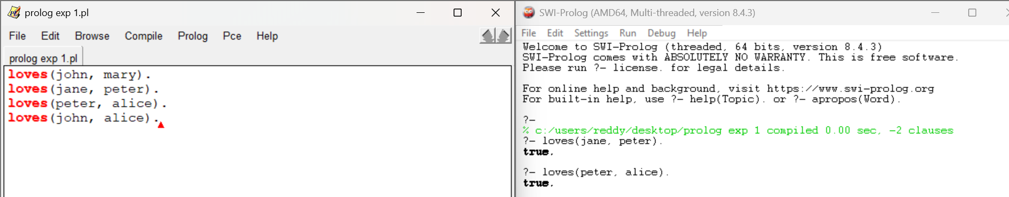
Experiment 32: Location
Code:
location(Chennai,tamilnadu).
location(madhurai, tamilnadu).
loction(Mumbai,maharastra).
stays(ravi, Chennai).
stays(asha,mumbai).
stays(akki,madhurai).
display(preson,city,state):-
stays(person,city),
location(city,state).
state_of_person((person,state):-
stays(person,city),
location(city,state).
Output:
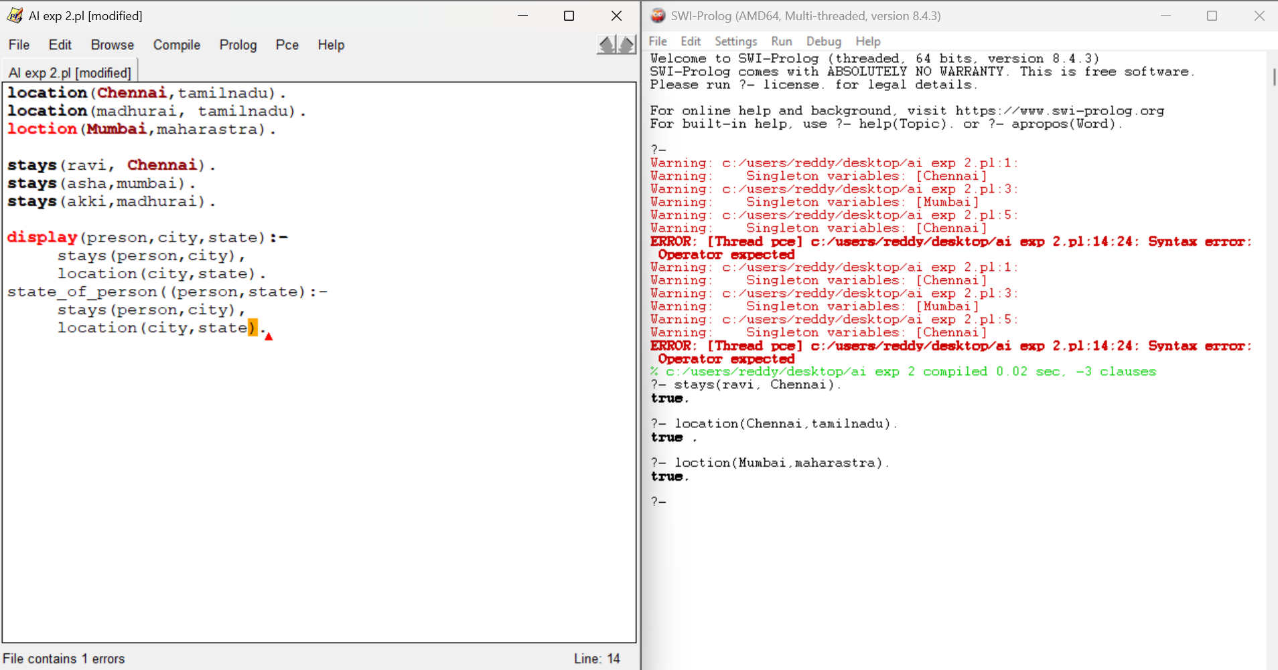
Experiment 33: Family members and Relationships
Code:
parent(john,bill).
parent(linda,bill).
parent(john,alice).
parent(linda,alice).
parent(bill,bob).
parent(alice,sue).
parent(tom,marry).
parent(susan,marry).
parent(bob,sam).
male(john).
male(bill).
male(bob).
male(tom).
male(sam).
female(linda).
female(alice).
female(susan).
female(sue).
female(marry).
sibling(x,y):-
parent(p,x),
parent(p,y),
x\=y.
brother(X,Y):-
sibling(x,y),
male(x).
sister(x,y):-
sibling(x,y),
female(x).
father(x,y):-
parent(x,y),
male(x).
mother(x,y):-
parent(x,y),
female(x).
grandparent(x,y):-
parent(x,z),
parent(z,y),
male(x).
grandfather(x,y)
grandparent(x,z),
parent(z,y),
male(x).

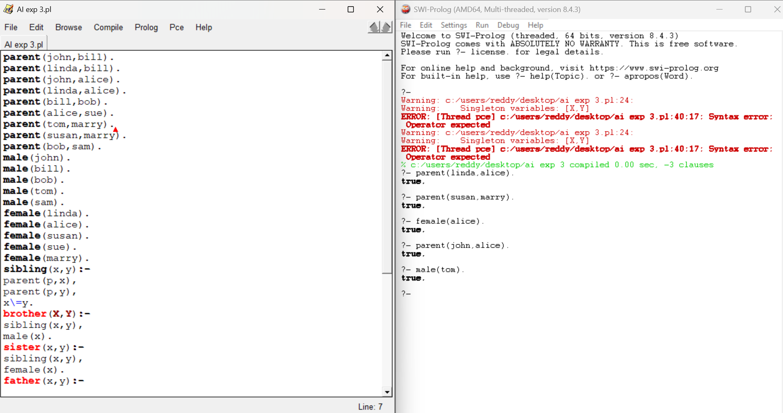
Experiment 34: Boy or Girl
Code:
% a) Every boy or girl is a child
child(X) :- boy(X).
child(X) :- girl(X).
% b) Every child gets a doll or a train or a lump of coal
gets(X, doll) :- child(X).
gets(X, train) :- child(X).
gets(X, coal) :- child(X).
% c) No boy gets any doll
gets(X, doll) :- child(X), \+ boy(X).
% d) No child who is good gets any lump of coal
gets(X, coal) :- child(X), \+ good(X).
% e) Jack is a boy
boy(jack).
Output:
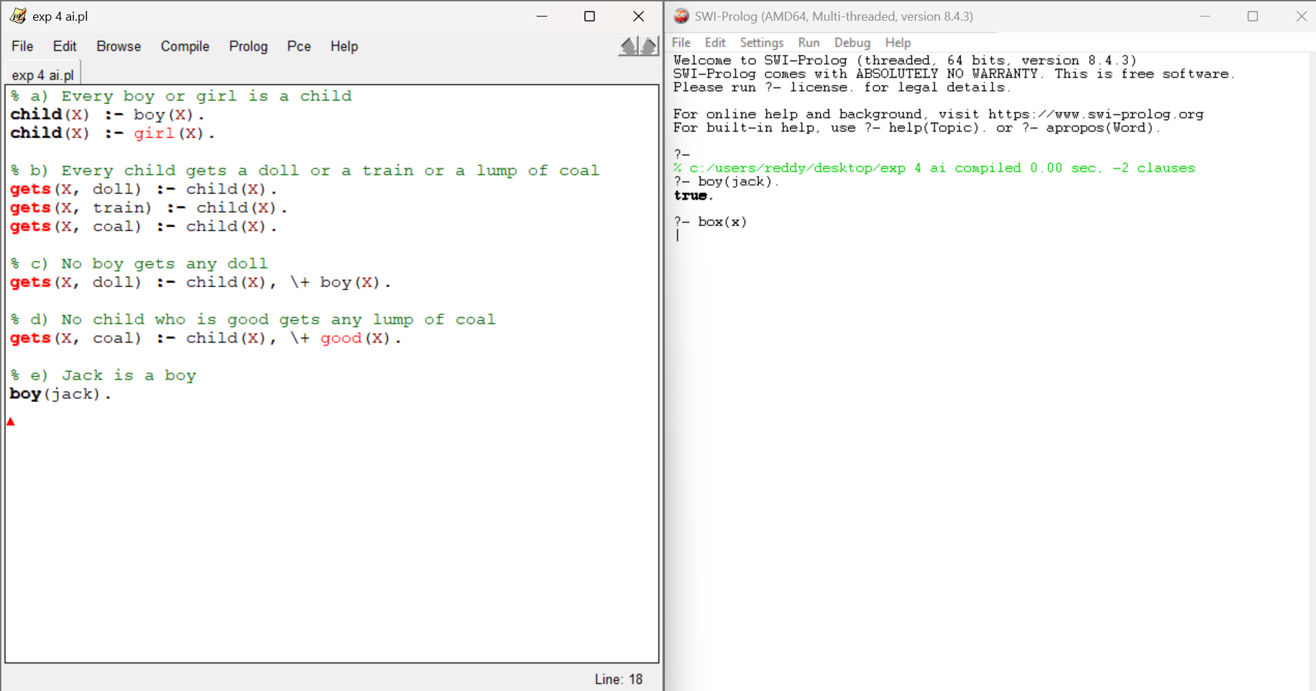
35: Celsius to Fahrenheit

Code:
c_to_f(C, F) :-
F is (C * 9/5) + 32.
below_freezing(C) :-
C<0.
Output:
